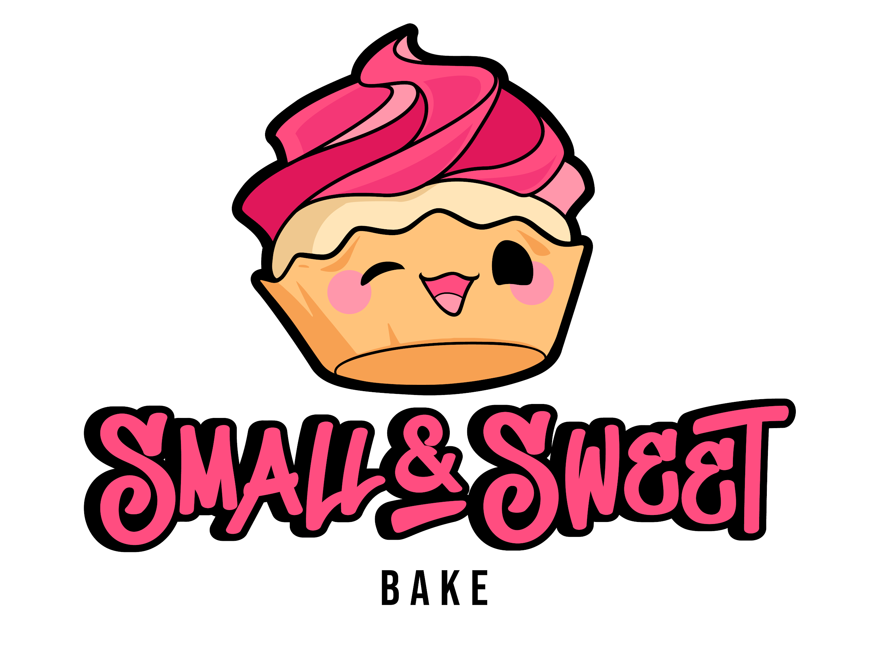
Azuki Bean Kinako Mochi- Gluten Free! Mochi cupcake (made with Mochiko rice flour) with red bean paste filled center topped with azuki bean ermine buttercream frosting decorated with mini mochi topping and dusting of kinako
Ingredients/Cake: rice flour, sugar, butter (milk), milk, yogurt (cultured milk), eggs, vanilla extract, baking powder, baking soda, salt Filling: red bean, sugar, canola oil, salt Frosting: butter (milk), milk, sugar, azuki bean paste, vegetable shortening (soybean oil, fully hydrogenated palm oil, partially hydrogenated palm and soybean oils, mono and diglycerides, TBHQ and citric acid), mini mochi (hydroxypropyl distarch phosphate, glutinous rice, maltose, sugar, salt) soybean powder, vanilla extract, salt
Black Sesame Banana- Roasted banana cupcake topped with a black sesame buttercream frosting decorated with a kawaii banana fondant disc
Ingredients/Cake: flour (bleached wheat flour, niacin, iron, thiamine mononitrate, riboflavin, enzymes, folic acid), banana, brown sugar, sugar, butter (milk), milk, yogurt (cultured milk), eggs, vanilla extract, baking powder, baking soda, salt Frosting: confectioner’s sugar (sugar, cornstarch), butter (milk), vegetable shortening (soybean oil, fully hydrogenated palm oil, partially hydrogenated palm and soybean oils, mono and diglycerides, TBHQ and citric acid), black sesame seeds, vanilla extract, salt
Curry Lime Mango- Vanilla cupcake with curry lime curd filled center and topped with a mango buttercream frosting
Ingredients/Cake: flour (bleached wheat flour, niacin, iron, thiamine mononitrate, riboflavin, enzymes, folic acid), sugar, butter (milk), milk, yogurt (cultured milk), eggs, vanilla extract, baking powder, baking soda, salt Curd: sugar, butter (milk), eggs, lime, curry powder Frosting: butter (milk), confectioner’s sugar (sugar, cornstarch), mango puree, vegetable shortening (soybean oil, fully hydrogenated palm oil, partially hydrogenated palm and soybean oils, mono and diglycerides, TBHQ and citric acid), mango extract, vanilla extract, salt
Lychee Matcha- Matcha green tea cupcake with a lychee cream-filled center topped with swirl of matcha green tea and lychee buttercream
Ingredients/Cake: flour (bleached wheat flour, niacin, iron, thiamine mononitrate, riboflavin, enzymes, folic acid), sugar, butter (milk), milk, yogurt (cultured milk), eggs, matcha powder, vanilla extract, baking powder, baking soda, salt Filling: lychee, butter (milk), sugar, cornstarch, vanilla extract, and lemon Frosting: butter (milk), confectioner’s sugar (sugar, cornstarch), vegetable shortening (soybean oil, fully hydrogenated palm oil, partially hydrogenated palm and soybean oils, mono and diglycerides, TBHQ and citric acid), matcha powder, lychee extract, vanilla extract, salt
Ube Coconut- Ube cupcake topped with a coconut buttercream frosting and decorated with coconut flakes
Ingredients/Cake: flour (bleached wheat flour, niacin, iron, thiamine mononitrate, riboflavin, enzymes, folic acid), sugar, butter (milk), milk, yogurt (cultured milk), eggs, ube extract, vanilla extract, baking powder, baking soda, salt Frosting: butter (milk), confectioner’s sugar (sugar, cornstarch), cream of coconut (coconut, sugar, water, polysorbate 60, sorbitan monostearate, salt, propylene glycol alginate, mono and diglycerides, citric acid, guar gum, locust bean gum), vegetable shortening (soybean oil, fully hydrogenated palm oil, partially hydrogenated palm and soybean oils, mono and diglycerides, TBHQ and citric acid), coconut, vanilla extract, salt
White Rabbit Candy- Inspired by a childhood favorite candy! Pieces of white rabbit candy baked into vanilla cupcake topped with white rabbit candy buttercream frosting and decorated with a white rabbit candy fondant disc
Ingredients/Cake: flour (bleached wheat flour, niacin, iron, thiamine mononitrate, riboflavin, enzymes, folic acid), sugar, butter (milk), milk, white rabbit candy (maltose, sugar, milk powder, cream, gelatin, glutinous rice paper (starch, water, glycerol monostearate, fatty acidester), yogurt (cultured milk), eggs, vanilla extract, baking powder, baking soda, salt Frosting: butter (milk), confectioner’s sugar (sugar, cornstarch), white rabbit candy, vegetable shortening (soybean oil, fully hydrogenated palm oil, partially hydrogenated palm and soybean oils, mono and diglycerides, TBHQ and citric acid), condense milk, vanilla extract, salt

